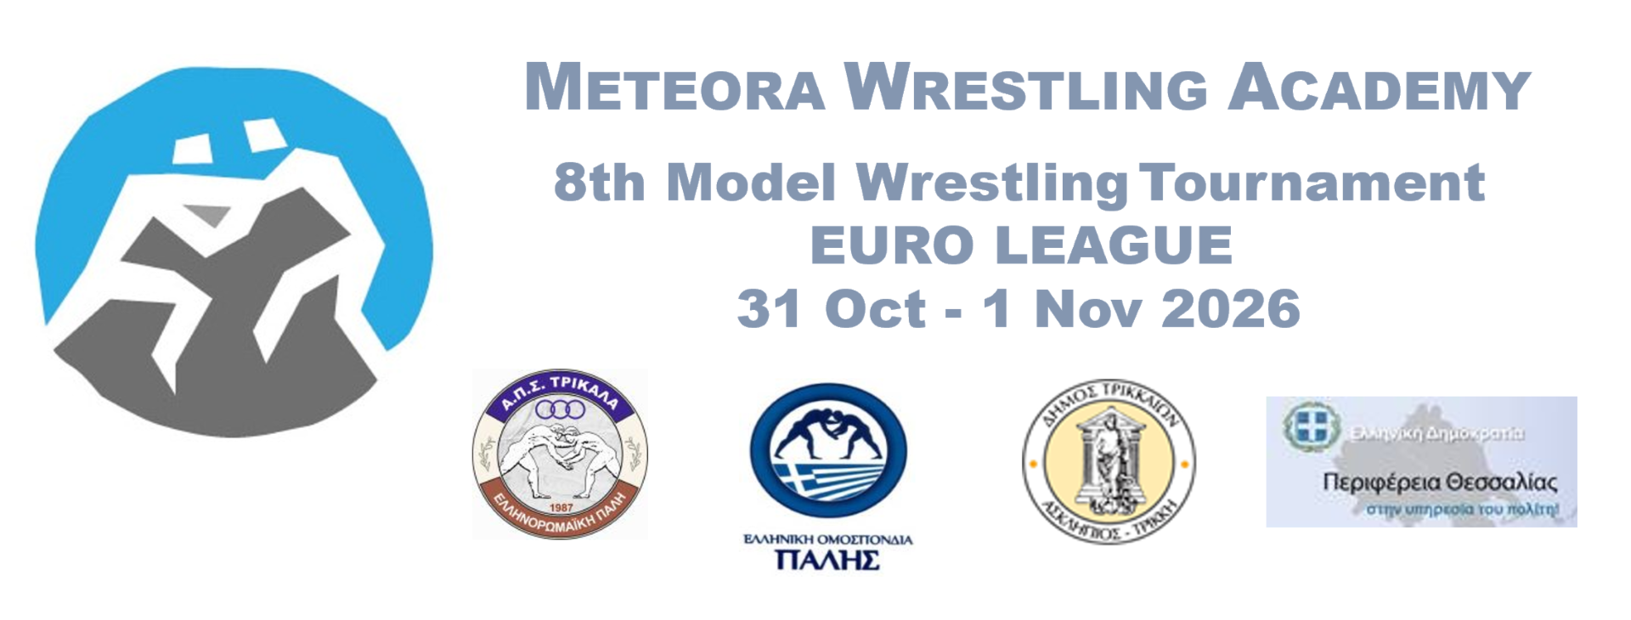
Trikala, Greece | October 31– November 1, 2026
Greco-Roman • Freestyle • Women Wrestling • U13-U15-U17-U20
One of the largest youth wrestling tournaments in Southeast Europe
Expected participation: 600+ wrestlers from 20+ countries
Organised by Meteora Wrestling Academy
Under the auspices of the Hellenic Wrestling Federation, Municipality of Trikala & Region of Thessaly

INTERNATIONAL PROFILE
The Meteora Wrestling Academy Tournament has developed into one of the fastest-growing youth wrestling events in the Balkans.
2025 Edition: 17 countries –400+ wrestlers
2026 Goal: 600+ wrestlers with strong international participation from Europe, Balkans, Caucasus & overseas teams.

EUROPEAN U17 GRECO-ROMAN EURO LEAGUE – OFFICIAL STAGE
This tournament will host an official stage of the U17 Greco-Roman European League.
These matches are held between team against team in 10 weight categories – team matches.
Core countries: Greece – Moldova - Ukraine – Croatia. Confirmed international teams include Kyrgyzstan, Armenia , Georgia , Serbia , Hungary and other strong wrestling nations. Guest teams may participate and collect points for the league ranking.

SPECIAL AWARDS
Grand Champion Belt – Best wrestler of the entire tournament
Euro League U17 MVP – Champion Belt
Team trophies & individual medals

VENUE
Municipal Indoor Wrestling Hall, Trikala – Greece
Easy access from Thessaloniki & Athens international airports.
Organising committee can assist with accommodation, meals and local transport.

COMPETITION PROGRAM
Friday – October 30, 2026
18:00–19:00 Draws , Technical Meeting and weight in for international clubs (and Euro league)
Saturday – October 31, 2026
Greco-Roman Wrestling (All age categories )
10:00–11:00 Medical & weigh-in and final draws (Greek clubs)
12:00–17:00 Qualification rounds
17:00–17:30 Opening ceremony
17:30–20:00 Finals
Sunday – November 1, 2026
Grego-Roman U17 Euro League (2010-2011-2012*)
10:00 – 13:00
Freestyle & Women Wrestling
10:00–11:00 Medical & weigh-in (Greek clubs)
12:00–17:00 Qualification rounds
17:30–20:00 Finals & Grand Champion ceremony

AGE CATEGORIES
Greco-Roman:
- U13 (2014-2015) : 43 , 48 , 54 , 60 , 75
- U15 (2012-2013) : 44 , 48 , 57 , 62 , 68 , 75
- U17 (2010-2011) : 45 , 48 , 51, 55 , 60 , 65 , 71 , 80 , 92, 110
- U20 (2007-2008-2009) : 55 , 60 , 67 , 77 , 87 , 97
Freestyle:
- U13 (2014-2015) : 43 , 48 , 54 , 60 , 75
- U15 (2012-2013) : 44 , 48 , 57 , 62 , 68 , 75
- U17 (2011-2010) : 51, 55 , 60 , 65 , 71 , 80 , 92
- U20 (2007-2008-2009) : 65 , 74 , 86 , 97

Women Wrestling:
- U13 (2014-2015) : 47 , 52 , 58
- U15 (2012-2013) : 54 , 58 , 62
- U17 (2011-2010) : 53 , 57, 61 , 65 , 73
(All Weight categories according to UWW rules +1 kg tolerance)

PARTICIPATION for tournament
Entry fee: 20€ per athlete
Late registration (after October 1): 25€ per athlete
EUROPEAN U17 GRECO LEAGUE (2010-2011-2012*)
Participation in the league ranking is optional.
League participation fee:
- Up to 5 athletes: 70€ per team
- 6–10 athletes: 120€ per team
Includes:
- Official league ranking
- MVP award eligibility
Core league countries and stages: Greece, Moldova , Ukraine ,Croatia. Confirmed international teams include Kyrgyzstan, Armenia , Georgia, Serbia , Hungary and other strong wrestling nations.

REGISTRATION & CONTACT
Preliminary entries: meteorawrestlingacademy@gmail.com
Final entries deadline: October 25, 2026
WhatsApp / Tel: (+30 6978982088)
Facebook & Instagram: Meteora Wrestling Academy

